8. House

Plovdiv, Plovdiv district, 30 Radetcy Str.

GPS N 42º08’14.6” and E 24º44’26.5”

The house is with 2 floors and with basement.

The house is with 2 floors and basement. On the first floor nobody lives. Only on the second.

6 CATS

GTS: 4 PCH brown; 5 MDC yellow; 5 MCH black

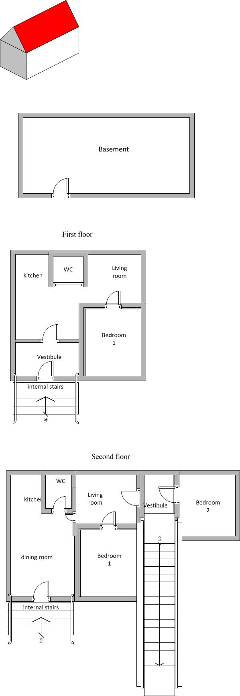

E-perm

pair of CATS

relevant GTS